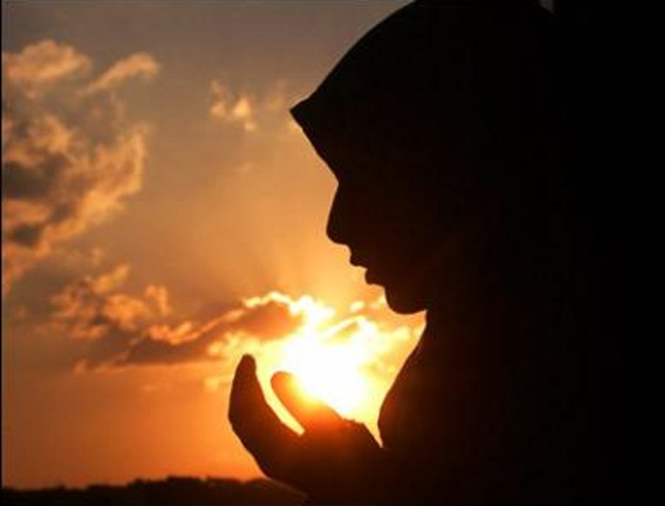Mai bhi to insaan hu.

Aalishan hu, budhiman hu.

Is hi desh ka mai jawaan hu.

Hua aatankwad mera jihad?

Kyuki mazhab se mai musalmaan hu?

Khoya hai maine bhi apna is ghor andhere mei.

Fir bhi khada kia jata hai mujhko shaq k ghere mei.

Yeh nahi mera kasoor  
ki mera mazhab kisi aatanki se mel khata hai

Ya, mere mazhab ka ek aadmi tum par goli chalata hai.

Aisi ghatnao mei mera bhi koi marta hai.

Arey puchke to dekho,  
musalman bhi aatankwad se utna hi darta hai.

Kya hua agar mai peshe se kasai hu?

Arey puchke to dekho har Hindustani ka bhai hu.

Kasai mera pesha hai, meri niyat nhi.

Kaha hai mera samman?  
Kya uski koi keemat nahi?

Hai ye sabki samasya,  
ise mazhabi kehkar mat taalo.

Kisi sangathan k kaam ko poori kaum par mat daaalo.

Kyo yaad karte ho unko jinhone desh ko jalaya hai?

Hai aise anek musalman jinhone desh ko sammaan dilaya hai.

Arey karo inko bhi yaad.

Islam ka matlab nahi hai aatankwad.

Kisi ek mazhab ki nahi,  
aatankwad poore desh ki samasya hai.

Nirantar iska virodh karna har Hindustani ki tapasya hai.

Kisne kaha aatankwad ki jad Islam hai?

Doosro par baat taal dene ka shauk bohot aam hai.

Apne dimag se ye fitoor mitao.

Asli Hindustani ho to Hindustan banker awaz uthao.

Ekjut ho sab to is ekta k virudh kaun ladega?

Aur jab tak mazhab k naam pe batoge,  
Tab tak aatankwad har nagrik ke dil mei badhega.

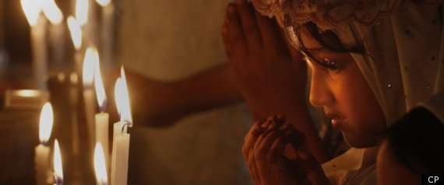

**AMAN KAUSHIK**